# Day 16&17

**Task 1: The Knight’s Tour Problem**

Create a function bool SolveKnightsTour(int[,] board, int moveX, int moveY, int moveCount, int[] xMove, int[] yMove) that attempts to solve the Knight's Tour problem using backtracking. The function should return true if a solution exists and false otherwise. The board represents the chessboard, moveX and moveY are the current coordinates of the knight, moveCount is the current move count, and xMove[], yMove[] are the possible next moves for the knight. Fill the chessboard such that the knight visits every square exactly once. Keep the chessboard size to 8x8.

**Program:**

package Assignments.Day16and17;  
  
import java.util.Arrays;  
  
public class Task1 {  
  
 private static final int N = 8; // Chessboard size  
  
 public static boolean isValidMove(int x, int y, int[][] board) {  
 return x >= 0 && x < N && y >= 0 && y < N && board[x][y] == -1;  
 }  
  
 public static boolean solveKnightsTour(int[][] board, int x, int y, int moveCount, int[] xMove, int[] yMove) {  
 if (moveCount == N * N) {  
 // All squares visited  
 return true;  
 }  
  
 for (int i = 0; i < N; i++) {  
 int nextX = x + xMove[i];  
 int nextY = y + yMove[i];  
 if (isValidMove(nextX, nextY, board)) {  
 board[nextX][nextY] = moveCount;  
 if (solveKnightsTour(board, nextX, nextY, moveCount + 1, xMove, yMove)) {  
 return true;  
 }  
 board[nextX][nextY] = -1; // Backtrack  
 }  
 }  
  
 return false;  
 }  
  
 public static void main(String[] args) {  
 int[][] board = new int[N][N];  
 for (int i = 0; i < N; i++) {  
 Arrays.fill(board[i], -1);  
 }  
  
 int[] xMove = {2, 1, -1, -2, -2, -1, 1, 2};  
 int[] yMove = {1, 2, 2, 1, -1, -2, -2, -1};  
  
 board[0][0] = 0;  
 boolean solutionExists = solveKnightsTour(board, 0, 0, 1, xMove, yMove);  
  
 if (solutionExists) {  
 System.out.println("Knight's Tour solution exists:");  
 for (int[] row : board) {  
 System.out.println(Arrays.toString(row));  
 }  
 } else {  
 System.out.println("No Knight's Tour solution exists.");  
 }  
 }  
}

**Output:**

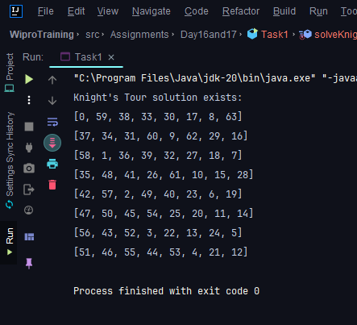

**Task 2: Rat in a Maze**

Implement a function bool SolveMaze(int[,] maze) that uses backtracking to find a path from the top left corner to the bottom right corner of a maze. The maze is represented by a 2D array where 1s are paths and 0s are walls. Find a rat's path through the maze. The maze size is 6x6.

**Program:**

package Assignments.Day16and17;  
  
import java.util.Arrays;  
  
public class Task2 {  
  
 private static final int N = 6; // Maze size  
  
 public static boolean isValidMove(int x, int y, int[][] maze) {  
 return x >= 0 && x < N && y >= 0 && y < N && maze[x][y] == 1;  
 }  
  
 public static boolean solveMaze(int[][] maze, int x, int y, int[][] path) {  
 if (x == N - 1 && y == N - 1) {  
 // Reached the bottom right corner  
 path[x][y] = 1;  
 return true;  
 }  
  
 if (isValidMove(x, y, maze)) {  
 path[x][y] = 1;  
  
 // Move right  
 if (solveMaze(maze, x, y + 1, path)) {  
 return true;  
 }  
 // Move down  
 if (solveMaze(maze, x + 1, y, path)) {  
 return true;  
 }  
  
 // Backtrack  
 path[x][y] = 0;  
 }  
  
 return false;  
 }  
  
 public static void main(String[] args) {  
 int[][] maze = {  
 {1, 0, 1, 1, 1, 0},  
 {1, 1, 1, 0, 1, 1},  
 {0, 0, 1, 1, 0, 1},  
 {1, 0, 0, 1, 1, 1},  
 {1, 1, 1, 0, 0, 1},  
 {1, 1, 1, 1, 1, 1}  
 };  
  
 int[][] path = new int[N][N];  
 boolean solutionExists = solveMaze(maze, 0, 0, path);  
  
 if (solutionExists) {  
 System.out.println("Rat's path through the maze:");  
 for (int[] row : path) {  
 System.out.println(Arrays.toString(row));  
 }  
 } else {  
 System.out.println("No solution exists.");  
 }  
 }  
}

**Output:**

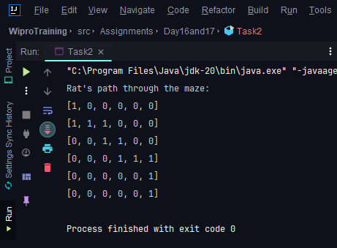

**Task 3: N Queen Problem**

Write a function bool SolveNQueen(int[] board, int col) in java that places N queens on an N x N chessboard so that no two queens attack each other using backtracking. Place N queens on the board such that no two queens can attack each other. Use a standard 8x8 chessboard.

**Program:**

package Assignments.Day16and17;

import java.util.Arrays;

public class Task3 {

private static final int N = 8;

public static boolean isValidMove(int[][] board, int row, int col) {

for (int i = 0; i < row; i++) {

if (board[i][col] == 1 ||

(col - (row - i) >= 0 && board[i][col - (row - i)] == 1) ||

(col + (row - i) < N && board[i][col + (row - i)] == 1)) {

return false;

}

}

return true;

}

public static boolean solveNQueens(int[][] board, int row) {

if (row == N) {

return true;

}

for (int col = 0; col < N; col++) {

if (isValidMove(board, row, col)) {

board[row][col] = 1;

if (solveNQueens(board, row + 1)) {

return true;

}

board[row][col] = 0;

}

}

return false;

}

public static void main(String[] args) {

int[][] board = new int[N][N];

boolean solutionExists = solveNQueens(board, 0);

if (solutionExists) {

System.out.println("N-Queens solution:");

for (int[] row : board) {

System.out.println(Arrays.toString(row));

}

} else {

System.out.println("No solution exists.");

}

}

}

**Output:**

